ARRAYS

An array is a data structure that contains a number of elements stored in contiguous memory locations. Arrays are of same data type and can be easily accessed.

Array is a data structure (means way to store data in memory) , in which data is stored next to each other in the memory. And the type of data (datatype) is same. this helps in easy access of elements of arrays.

Why arrays?

Syntax for creating an array

Datatype nameofarray**[**size**]** ;

Arrays vs variables in memory

Structure of an array

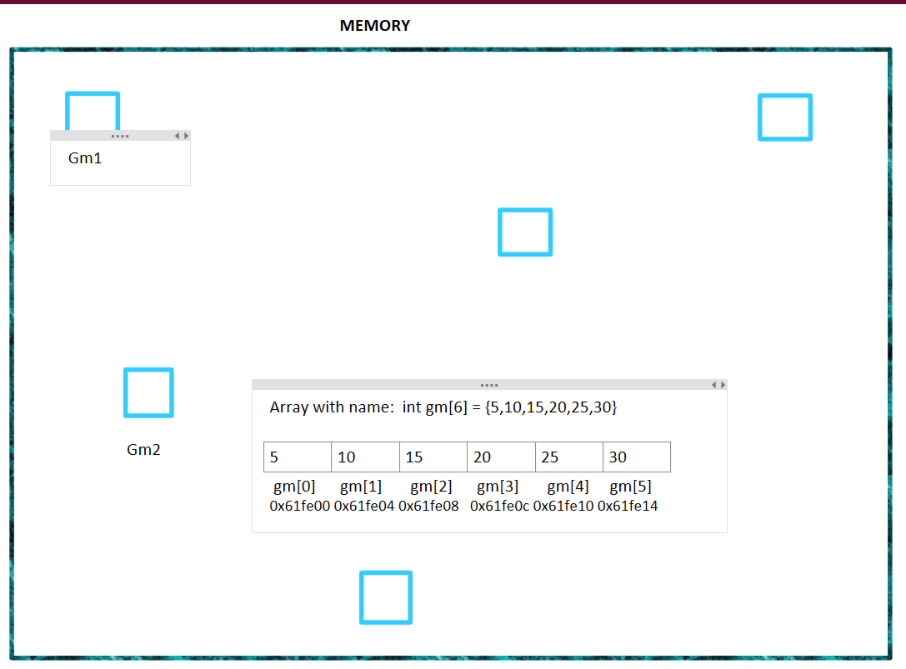

STATIC ARRAY VS DYNAMIC ARRAY

|  |  |
| --- | --- |
| Static | Dynamic |
| When we create before executing | Array created at runtime while compiling//on black screen(console) |
| Syntax: int arr[5]; | int* arr = new int[10]; |
| Created/stored in Stack memory | Created/stored in heap memory |
| We don’t manage memory | We manage memory ourselves. Means that once we create dynamic array, it is not deleted/set free until we delete it ourself or computer is restarted |
| Used when we know the size of elements and it doesn’t change over time | Used when we do not know the size of elements |
|  |  |
|  |  |

Ways to store elements in an array:  
1. At the time of declaration:

* int arr[5] = {5,10,15,20,25};

2. after declaration:

1. int arr[5];
3. arr[0] = 5;
4. arr[1] = 10;
5. arr[2] = 15;
6. arr[3] = 20;
7. arr[4] = 25;

PRACTICE PROBLEMS

1. Print elements of an array
   1. Using for loop
      1. #include <iostream>
      2. using namespace std;
      3. int main()
      4. {
      5. int arr[] = {55,10,15,20,25};
      6. int siz = sizeof(arr) / sizeof(arr[0]);
      7. //print/display elements of an array
      8. //write program to access/print elements of an array
      9. for(int i=0; i < siz; i++)
      10. {
      11. cout<<arr[i]<<endl;
      12. }
      13. return 0;
      14. }
   2. Using while loop
      1. #include <iostream>
      2. using namespace std;
      3. int main()
      4. {
      5. int arr[] = {500,1000,15,20,25};
      6. int siz = sizeof(arr) / sizeof(arr[0]);
      7. //print/display elements of an array
      8. int i = 0;
      9. while(i<siz)
      10. {
      11. cout<<arr[i]<<endl;
      12. i++;
      13. }
      14. return 0;
      15. }
   3. Using do while loop
      1. #include <iostream>
      2. using namespace std;
      3. int main()
      4. {
      5. int arr[] = {500,1000,15,20,25};
      6. int siz = sizeof(arr) / sizeof(arr[0]);
      7. //print/display elements of an array
      8. int i = 0;
      9. do
      10. {
      11. cout<<arr[i]<<endl;
      12. i++;
      13. }while(i<siz);
      14. return 0;
      15. }
2. Take elements of an array from user
   1. #include <iostream>
   2. using namespace std;
   3. int main()
   4. {
   5. int arr[6];
   6. //for getting data of array from user
   7. for(int i=0; i<6 ;i++)
   8. {
   9. cout<<"Enter element of array at index "<<i<<" : ";
   10. cin>> arr[i];
   11. }
   12. cout<<"\n\n";
   13. //printing elements of an array
   14. for(int i=0; i<6; i++)
   15. {
   16. cout<<"element at index "<<i<<" is : "<<arr[i]<<endl;
   17. }
   18. return 0;
   19. }
3. Find size of an array
   1. int num;
   2. //calculate size of a variable
   3. cout<<"size of int variable num is : "<< sizeof(num)<<endl;
   4. //sizeof() returns size of a variable/array in bytes
   5. //how to calculate size of an array
   6. int arrsize = sizeof(arr) / sizeof(arr[0]);
   7. cout<<"elements in array arr are: "<<arrsize<<endl;
4. Find sum of elements of array
   1. #include <iostream>
   2. using namespace std;
   3. int main()
   4. {
   5. const int siz = 6;
   6. int arr[siz]= {5,10,15,20,25,30};
   7. int sum = 0;
   8. for(int i=0; i<siz; i++)
   9. {
   10. sum = sum + arr[i];
   11. }
   12. cout<<"Total sum of elements of array is : "<<sum<<endl;
   13. return 0;
   14. }
   15. DRY RUN:
   16. 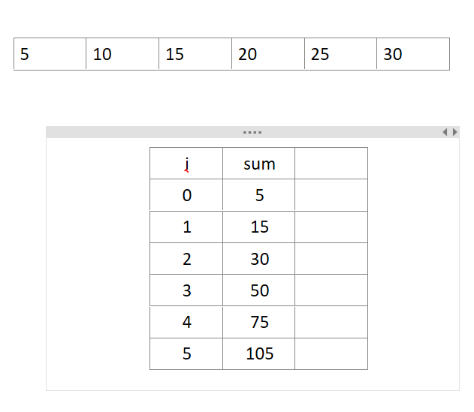
5. Find average of elements of array
   1. #include <iostream>
   2. using namespace std;
   3. int main()
   4. {
   5. const int siz = 6;
   6. int arr[siz]= {5,10,15,20,25,31};
   7. int sum = 0;
   8. float avg = 0;
   9. for(int i=0; i<siz; i++)
   10. {
   11. sum = sum + arr[i];
   12. }
   13. avg = (float)sum/siz; //average of array
   14. cout<<"Total sum of elements of array is : "<<sum<<endl;
   15. cout<<"average of array is : "<<avg<<endl;
   16. return 0;
   17. }
6. Check if each number in an array is an even or odd number
   1. #include <iostream>
   2. using namespace std;
   3. int main()
   4. {
   5. const int siz = 6;
   6. int arr[siz]= {5,10,15,20,25,31};
   7. //Check if each number in an array is an even or odd number
   8. for(int i=0; i<siz; i++)
   9. {
   10. if(arr[i]%2 == 0)
   11. {
   12. cout<<arr[i]<<" is an even number"<<endl;
   13. }
   14. else
   15. {
   16. cout<<arr[i]<<" is an odd number"<<endl;
   17. }
   18. }
   19. return 0;
   20. }
7. Find maximum value of an array
   1. #include <iostream>
   2. using namespace std;
   3. int main()
   4. {
   5. const int siz = 6;
   6. int arr[siz]= {534,88,9348,29477,23443,2324};
   7. //find max element of given array
   8. int maxelement = arr[0];
   9. for(int i=1; i<siz; i++)
   10. {
   11. if(arr[i] > maxelement)
   12. {
   13. maxelement = arr[i];
   14. }
   15. }
   16. cout<<"MAX ELEMENT IS : "<<maxelement<<endl;
   17. return 0;
   18. }
8. Write program to take elements of an array as input from user(array size 6) and then find max element from them and display it on the screen
   1. #include <iostream>
   2. using namespace std;
   3. int main()
   4. {
   5. const int siz = 6;
   6. int arr[siz];
   7. //take elements of array from user
   8. //and then find maximum element from them
   9. //taking elements as input
   10. for(int i=0; i<siz; i++)
   11. {
   12. cout<<"Enter index "<<i<<" value: ";
   13. cin>>arr[i];
   14. }
   15. //code to find max element from array
   16. int maxelement = arr[0];
   17. for(int i=1; i<siz; i++)
   18. {
   19. if(arr[i] > maxelement)
   20. {
   21. maxelement = arr[i];
   22. }
   23. }
   24. cout<<"MAX ELEMENT IS : "<<maxelement<<endl;
   25. return 0;
   26. }
9. Count the even numbers in an array
   1. #include <iostream>
   2. using namespace std;
   3. int main()
   4. {
   5. const int siz = 6;
   6. int arr[siz]= {5,10,15,20,25,31};
   7. //Check if each number in an array is an even or odd number
   8. int oddcounter = 0;
   9. int evencounter = 0;
   10. for(int i=0; i<siz; i++)
   11. {
   12. if(arr[i]%2 == 0)
   13. {
   14. cout<<arr[i]<<" is an even number"<<endl;
   15. evencounter++;
   16. }
   17. else
   18. {
   19. oddcounter++;
   20. cout<<arr[i]<<" is an odd number"<<endl;
   21. }
   22. }
   23. cout<<"\nTotal odd elements are: "<<oddcounter<<endl;
   24. cout<<"\nTotal even elements are: "<<evencounter<<endl;
   25. return 0;
   26. }
10. Count the odd numbers in an array
    1. #include <iostream>
    2. using namespace std;
    3. int main()
    4. {
    5. const int siz = 6;
    6. int arr[siz]= {5,10,15,20,25,31};
    7. //Check if each number in an array is an even or odd number
    8. int oddcounter = 0;
    9. for(int i=0; i<siz; i++)
    10. {
    11. if(arr[i]%2 == 0)
    12. {
    13. cout<<arr[i]<<" is an even number"<<endl;
    14. }
    15. else
    16. {
    17. oddcounter++;
    18. cout<<arr[i]<<" is an odd number"<<endl;
    19. }
    20. }
    21. cout<<"\nTotal odd elements are: "<<oddcounter<<endl;
    22. return 0;
    23. }
11. Count sum of odd numbers in an array
    1. #include <iostream>
    2. using namespace std;
    3. int main()
    4. {
    5. const int siz = 6;
    6. int arr[siz]= {5,10,15,20,25,31};
    7. //Check if each number in an array is an even or odd number
    8. int sum =0;
    9. for(int i=0; i<siz; i++)
    10. {
    11. if(arr[i]%2 == 0)
    12. {
    13. cout<<arr[i]<<" is an even number"<<endl;
    14. }
    15. else
    16. {
    17. cout<<arr[i]<<" is an odd number"<<endl;
    18. sum += arr[i];
    19. }
    20. }
    21. cout<<"total sum of odd numbers is : "<<sum<<endl;
    22. return 0;
    23. }
12. Ask user to enter a number and see if that number exist in the array   
    arr[10] = {2,3,4,5,6,7,8,9,10,11}
    1. #include <iostream>
    2. using namespace std;
    3. int main()
    4. {
    5. const int siz = 10;
    6. int arr[siz] = {2,3,4,5,6,7,8,9,10,11};
    7. //Ask user to enter a number and see if that number exist in the array
    8. // arr[10] = {2,3,4,5,6,7,8,9,10,11}
    9. int num;
    10. cout<<"Enter a number to check if it exist in array : ";
    11. cin>>num;
    12. bool ifexist = 0;
    13. for(int i=0; i<siz ; i++)
    14. {
    15. if(arr[i] == num)
    16. {
    17. ifexist = true;
    18. }
    19. }
    20. if(ifexist == 1)
    21. {
    22. cout<<"Yes, this number exist in array"<<endl;
    23. }
    24. else
    25. {
    26. cout<<"This number doesn't exist in array"<<endl;
    27. }
    28. return 0;
    29. }
13. Delete element of an array
    1. #include <iostream>
    2. using namespace std;
    3. int main()
    4. {
    5. int siz = 10;
    6. int arr[siz] = {2,3,4,5,6,7,8,9,10,11};
    7. int ind;
    8. cout<<"Enter index of element to delete : ";
    9. cin>>ind;
    10. for(int i=ind ; i< siz-1; i++)
    11. {
    12. arr[i] = arr[i+1];
    13. }
    14. siz--;
    15. cout<<"new array is : "<<endl<<endl;
    16. for(int i=0;i<siz; i++)
    17. {
    18. cout<<arr[i]<<" ";
    19. }
    20. return 0;
    21. }
14. Take two arrays from user and see if the are same(means same value at same index)
    1. #include <iostream>
    2. using namespace std;
    3. int main()
    4. {
    5. //14. Take two arrays from user and see
    6. //if the are same(means same value at same index)
    7. int arr1[5];
    8. int arr2[5];
    9. cout<<"Enter 5 elements of first array:"<<endl;
    10. for(int i=0; i<5;i++)
    11. {
    12. cout<<"Enter arr1 index "<<i<<" : ";
    13. cin>>arr1[i];
    14. }
    15. cout<<"Enter 5 elements of second array:"<<endl;
    16. for(int i=0; i<5;i++)
    17. {
    18. cout<<"Enter arr2 index "<<i<<" : ";
    19. cin>>arr2[i];
    20. }
    21. bool issame = 1;
    22. for(int i=0; i<5; i++)
    23. {
    24. if(arr1[i] != arr2[i])
    25. {
    26. issame = 0;
    27. }
    28. }
    29. if(issame == 1)
    30. {
    31. cout<<"arrays are same"<<endl;
    32. }
    33. else
    34. {
    35. cout<<"arrays are different"<<endl;
    36. }
    37. return 0;
    38. }